

EMBEDDED SYSTEMS
ASSIGNMENT 02

SUBMITTED BY:
Fahad Khan : 23-SE-64

SUBMITTED TO:
DR. HUMA QAYYUM

DEPARTMENT OF SOFTWARE ENGINEERING.
UNIVERSITY OF ENGINEERING AND TECHNOLOGY
TAXILA

QUESTION 01 : DUAL SWITCH SECURITY ALERT SYSTEM
SOURCE CODE :
.include "m32def.inc"

; ==========================================
; INITIALIZATION
; ==========================================
; 1. Initialize Stack Pointer (Best Practice) ldi r16, high(RAMEND) out SPH, r16 ldi r16, low(RAMEND) out SPL, r16

; 2. Configure Ports ldi r16, 0x00 out DDRA, r16 ; Configure Port A as Input

ldi r16, 0xFF out DDRB, r16 ; Configure Port B as Output out DDRC, r16 ; Configure Port C as Output

; ==========================================
; MAIN LOOP
; ========================================== start:
in r16, PINA ; Read the current state of Port A andi r16, 0x03 ; Mask to only look at PA1 and PA0 (0b00000011)

; Condition 1: Both Active (1,1) -> SAFE -> All OFF cpi r16, 0x03
breq safe_state

; Condition 2: PA1 is 1, PA0 is 0 -> Turn ON LED1
cpi r16, 0x02 breq led1_on

; Condition 3: PA1 is 0, PA0 is 1 -> Turn ON LED2
cpi r16, 0x01 breq led2_on

; Condition 4: Both Inactive (0,0) -> Both LEDs ON + Buzzer ON
cpi r16, 0x00 breq critical_state

rjmp start ; Fallback loop

; ==========================================
; STATE SUBROUTINES
; ========================================== safe_state:
cbi PORTB, 0 ; Clear PB0 (LED1 OFF) cbi PORTB, 1 ; Clear PB1 (LED2 OFF) cbi PORTC, 0 ; Clear PC0 (Buzzer OFF) rjmp start

led1_on: sbi PORTB, 0 ; Set PB0 (LED1 ON) cbi PORTB, 1 ; Clear PB1 (LED2 OFF) cbi PORTC, 0 ; Clear PC0 (Buzzer OFF) rjmp start

led2_on: cbi PORTB, 0 ; Clear PB0 (LED1 OFF) sbi PORTB, 1 ; Set PB1 (LED2 ON) cbi PORTC, 0 ; Clear PC0 (Buzzer OFF) rjmp start

critical_state:
sbi PORTB, 0 ; Set PB0 (LED1 ON) sbi PORTB, 1 ; Set PB1 (LED2 ON) sbi PORTC, 0 ; Set PC0 (Buzzer ON) rjmp start

SCHEMATIC PICTURE :
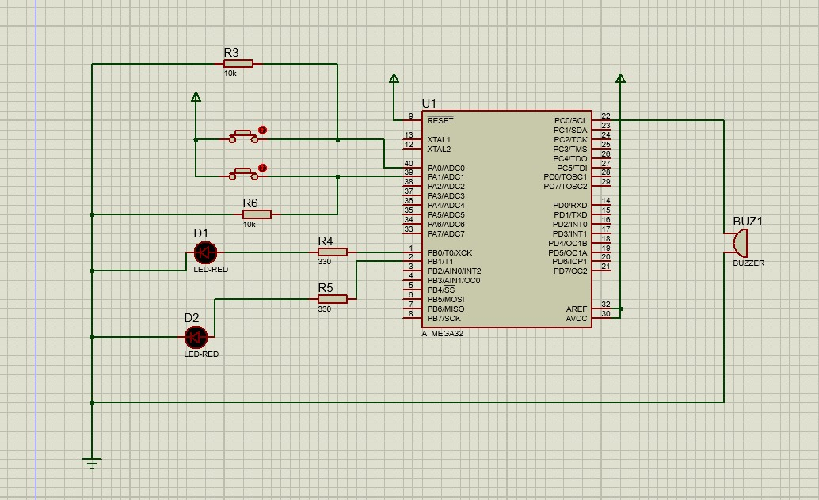

QUESTION 02 : SIMPLE SILENCE INDICATOR SYSTEM
SOURCE CODE :
.include "m32def.inc"

; ==========================================
; INITIALIZATION
; ==========================================
; Initialize Stack Pointer (Best Practice) ldi r16, high(RAMEND) out SPH, r16 ldi r16, low(RAMEND) out SPL, r16

; Configure Ports ldi r16, 0x00 out DDRA, r16 ; Configure Port A as Input (PA0 for the button)

ldi r16, 0xFF out DDRB, r16 ; Configure Port B as Output (PB0 for Green, PB1 for Red) out DDRC, r16 ; Configure Port C as Output (PC0 for Buzzer)

; ==========================================
; MAIN LOOP
; ========================================== start:
in r16, PINA ; Read the current state of Port A andi r16, 0x01 ; Mask to only look at PA0 (0b00000001)

; Check Condition: Button = 1 (Silence Mode)
cpi r16, 0x01 breq silence_mode

; If it's not 1, it must be 0 (Noise Condition) rjmp noise_mode

; ==========================================
; STATE SUBROUTINES
; ========================================== silence_mode: sbi PORTB, 0 ; Set PB0 (Green LED ON) cbi PORTB, 1 ; Clear PB1 (Red LED OFF) cbi PORTC, 0 ; Clear PC0 (Buzzer OFF) rjmp start

noise_mode: cbi PORTB, 0 ; Clear PB0 (Green LED OFF) sbi PORTB, 1 ; Set PB1 (Red LED ON) sbi PORTC, 0 ; Set PC0 (Buzzer ON) rjmp start

SCHEMATIC PICTURE :
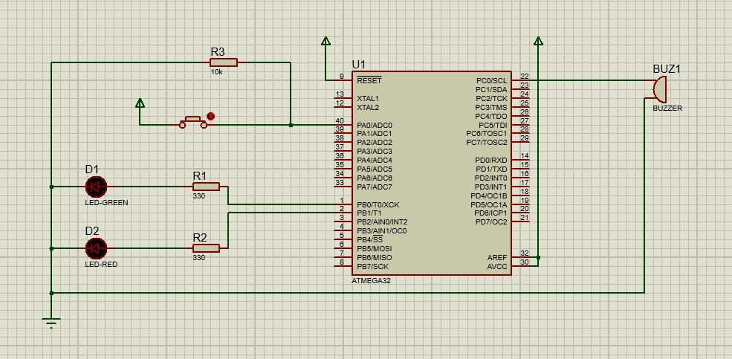

QUESTION 03 : TWO LEVEL WARNING INDICATOR SYSTEM
SOURCE CODE :
.include "m32def.inc"

; ==========================================
; INITIALIZATION
; ========================================== ldi r16, high(RAMEND) out SPH, r16 ldi r16, low(RAMEND) out SPL, r16

ldi r16, 0x00 out DDRA, r16 ; Configure Port A as Input (PA0, PA1 for Logic Inputs)

ldi r16, 0xFF out DDRB, r16 ; Configure Port B as Output (PB0, PB1 for LEDs) out DDRC, r16 ; Configure Port C as Output (PC0 for Buzzer)

; ==========================================
; MAIN LOOP
; ========================================== start:
in r16, PINA ; Read Port A andi r16, 0x03 ; Mask to only look at PA1 and PA0

; (0,0) -> Normal -> All OFF cpi r16, 0x00 breq state_normal

; (1,0) -> Level 1 Warning -> LED1 ON (Note: PA0 is 1, PA1 is 0)
cpi r16, 0x01 breq state_level1

; (0,1) -> Level 2 Warning -> LED2 ON (Note: PA0 is 0, PA1 is 1)
cpi r16, 0x02 breq state_level2

; (1,1) -> Critical -> Both LEDs ON + Buzzer ON
cpi r16, 0x03 breq state_critical

rjmp start

; ==========================================
; STATE SUBROUTINES
; ========================================== state_normal: cbi PORTB, 0 ; LED1 OFF cbi PORTB, 1 ; LED2 OFF cbi PORTC, 0 ; Buzzer OFF rjmp start

state_level1: sbi PORTB, 0 ; LED1 ON cbi PORTB, 1 ; LED2 OFF cbi PORTC, 0 ; Buzzer OFF rjmp start

state_level2: cbi PORTB, 0 ; LED1 OFF sbi PORTB, 1 ; LED2 ON cbi PORTC, 0 ; Buzzer OFF rjmp start

state_critical:
sbi PORTB, 0 ; LED1 ON sbi PORTB, 1 ; LED2 ON sbi PORTC, 0 ; Buzzer ON rjmp start

SCHEMATIC PICTURE :
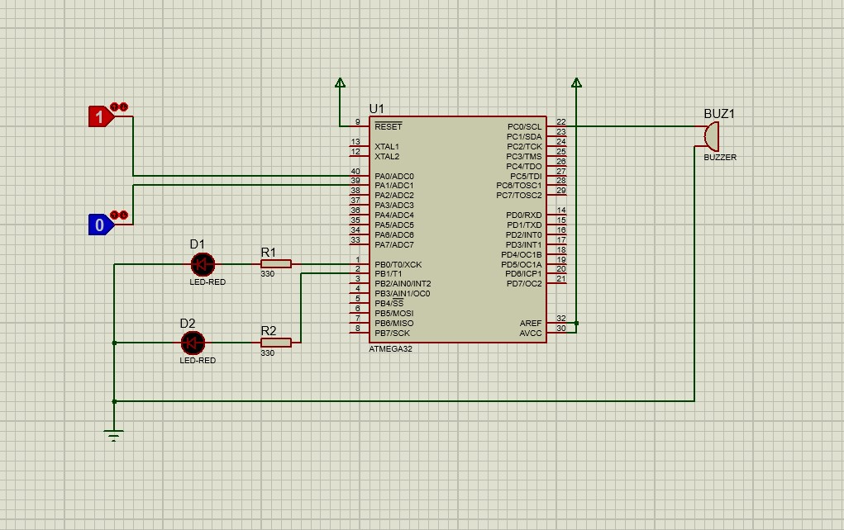

QUESTION 04 : SMART ENTRY INDICATOR SYSTEM
SOURCE CODE :
.include "m32def.inc"

; ==========================================
; INITIALIZATION
; ========================================== ldi r16, high(RAMEND) out SPH, r16 ldi r16, low(RAMEND) out SPL, r16

ldi r16, 0x00 out DDRA, r16 ; Configure Port A as Input (PA0 for Button)

ldi r16, 0xFF out DDRB, r16 ; Configure Port B as Output (PB0, PB1 for LEDs) out DDRC, r16 ; Configure Port C as Output (PC0 for Buzzer)

clr r19 ; r19 will act as our "Seconds" counter

; ==========================================
; MAIN LOOP
; ========================================== start: in r16, PINA andi r16, 0x01 cpi r16, 0x01 breq button_pressed

; --- State: Button is NOT pressed --- button_released:
clr r19 ; Instantly reset the long-press counter to 0 cbi PORTB, 0 ; LED1 OFF sbi PORTB, 1 ; LED2 ON (Entry Blocked) cbi PORTC, 0 ; Buzzer OFF rjmp start

; ==========================================
; STATE: BUTTON IS HELD DOWN
; ========================================== button_pressed: sbi PORTB, 0 ; LED1 ON (Entry Allowed) cbi PORTB, 1 ; LED2 OFF

; Check if we have held it long enough (The Threshold) cpi r19, 20 ; <--- CHANGE THIS NUMBER TO ADJUST THE DELAY TIME
brsh trigger_buzzer

; If we haven't reached the threshold, add 1 to our counter inc r19

; --- The Delay Block (Wastes time so it doesn't count instantly) --- ldi r21, 255 ; Outer loop counter delay_outer:
ldi r20, 255 ; Inner loop counter
delay_inner:
; CRUCIAL: Constantly check if they let go of the button during the delay!
in r16, PINA andi r16, 0x01 cpi r16, 0x01 brne button_released ; If released early, abort the delay and reset!

dec r20 brne delay_inner dec r21 brne delay_outer
; -------------------------------------------------------------------

rjmp start ; Go back to the top to check again

trigger_buzzer: sbi PORTC, 0 ; Buzzer ON rjmp start ; Keep looping (if button is released, it jumps to 'button_released')

SCHEMATIC PICTURE :
